**Project Title**: Trends in Drug Overdoses in the United States

**Group Members**: Justin Chow, Zhanna, Shimsy Varkey, Sam Jebreen

**GitHub repository Link:** <https://github.com/jebreensa/Project-2_Group12>

**Dataset:**

**VSRR Provisional Drug Overdose Death Counts:** <https://healthdata.gov/dataset/vsrr-provisional-drug-overdose-death-counts>

Description: The VSRR (National Vital Statistics System) on Drug Overdose is an aggregation of data from the CDC regarding drug overdoses across the United States. Ostensibly, this is stratified by 3 key categories:

* Month and Year (available from January 2015 thru April 2020)
* State (Washington DC stats are also included)
* Drug types (Cocaine, Heroin, Meth, prescription opioids, psychostimulants)

*Example Layout*

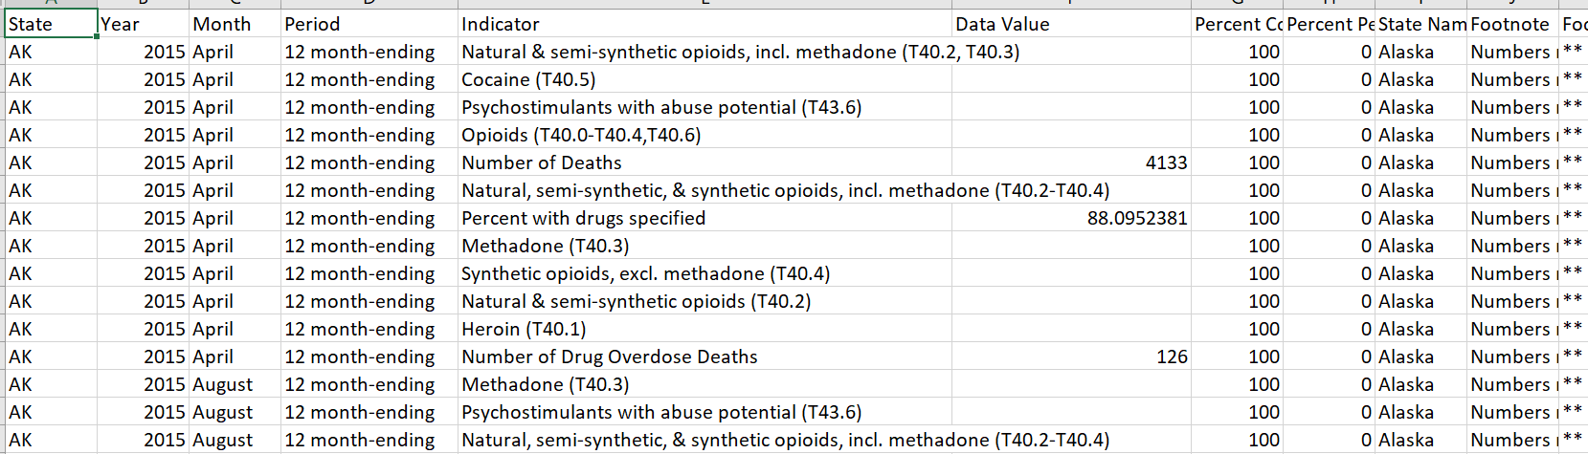

**The Story to be told:**

The idea to sell is to illustrate where overdoses are increasing or decreasing over time. To illustrate this, it would be best to have selectable dropdowns along the key categories. The top illustration would ideally be a line graph displaying the total deaths in aggregate from across the US, with a dropdown to select month/year.

Website Header block

*Description of dataset and summary*

Dropdown: Drug Type

Line chart showing aggregate deaths

Y-axis: # of deaths

X-Axis: Time

*Sells the bigger picture*

Dropdown: month/year

Dropdown: month/year

Bar Chart

y-axis: # of deaths

x-axis: drug type

*for comparison*

Bar Chart

y-axis: # of deaths

x-axis: drug type

*for comparison*

Dropdown: State

Dropdown: State